RDS Relational database Service

- Create MariaDB DB on EC2.
Overview of what I will do
- Launch an EC2 instance (choose AMI, instance type, key pair, security group).
- SSH to the instance.
- Install MariaDB (commands differ slightly by distro).
- Run the secure setup (mysql_secure_installation) and create DB/user.
- Configure network access securely (EC2 Security Group + bind-address + firewall).
STEP 1: OPEN ONE EC2
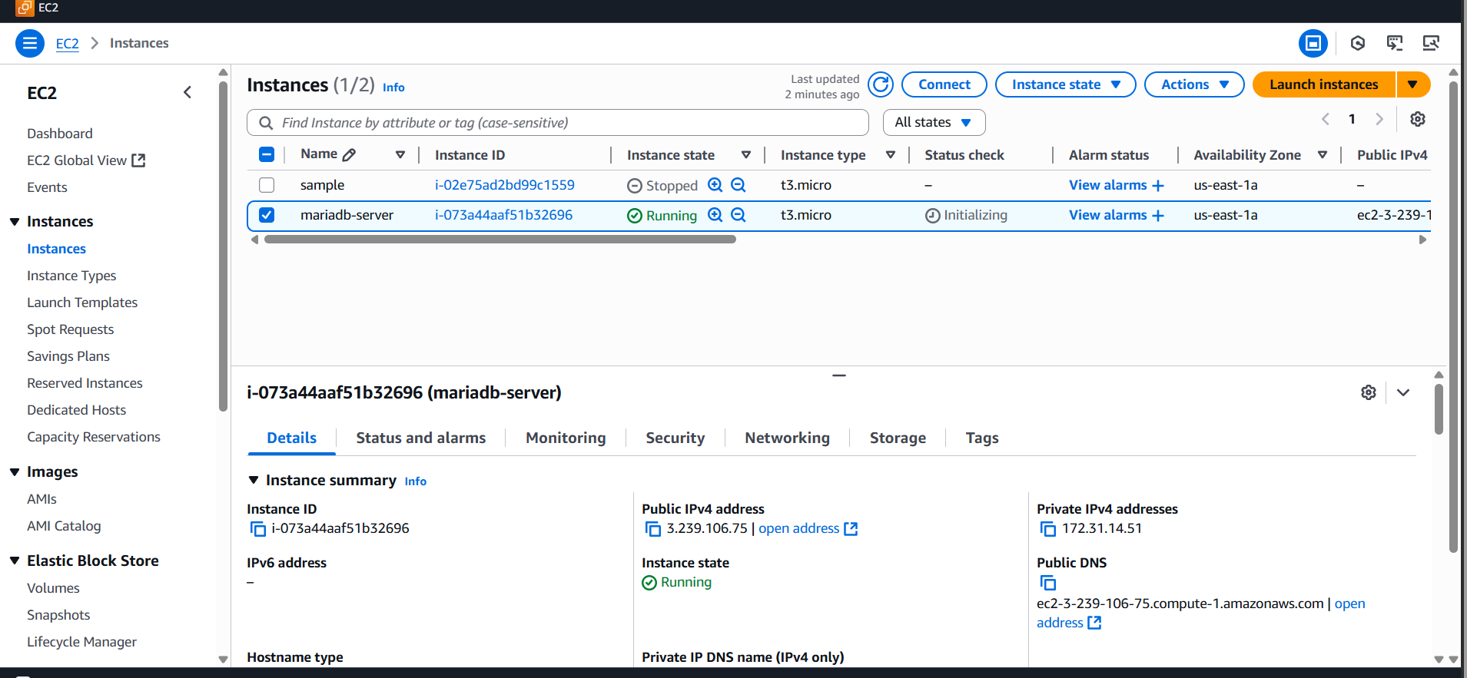
STEP 2:
SSH into the instance
From your local machine:
Step 2:
Install MariaDB
Begin Configuration :
sudo su -
yum -y install mariadb-server wget
systemctl enable mariadb
systemctl start mariadb
follow these steps to install
# update packages
sudo yum update -y
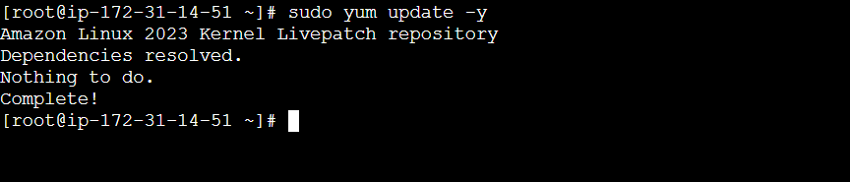
# install MariaDB server
sudo dnf install -y mariadb105-server (or) sudo yum install -y mariadb-server
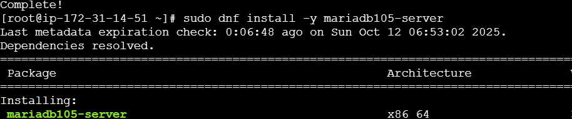
# start and Enable and start the service
sudo systemctl start mariadb
sudo systemctl enable mariadb
# check status
sudo systemctl status mariadb
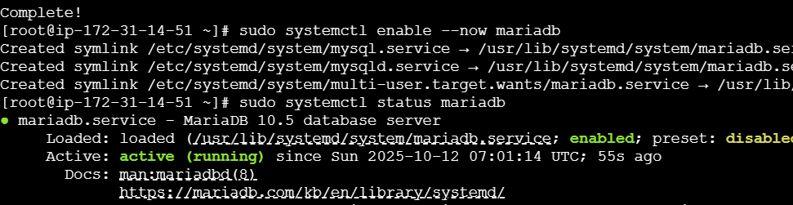

You can verify version:
mariadb --version
Step 4) Secure the installation
Run the interactive secure script:
sudo mysql_secure_installation
  - it will ask, please read the details, give your details, and carefully

  - Set a root password (or confirm the auth plugin)
  - Remove anonymous users
  - Disallow remote root login
  - Remove test database
  - Reload privilege tables

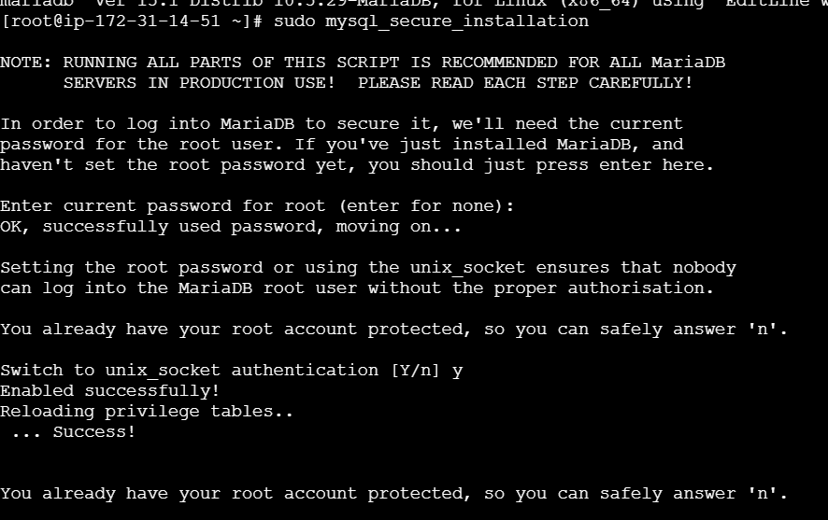
Step 5 : data base setup
Create a database and dedicate use
# login as root (no password on many installs; sudo runs as unix socket)
sudo mariadb
sudo lsof -I tcp:3306
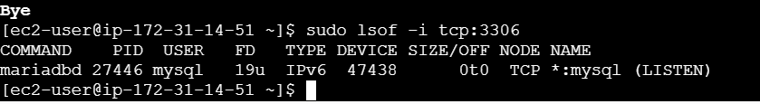

DBName=ec2db
DBPassword=admin123456
DBRootPassword=admin123456
DBUser=ec2dbuserEcho DBName = it show our username
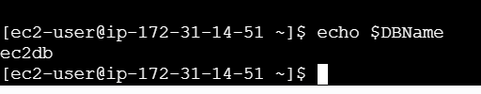
Database Setup on EC2 Instance:
===============================
echo "CREATE DATABASE ${DBName};" >> /tmp/db.setup
echo "CREATE USER '${DBUser}' IDENTIFIED BY '${DBPassword}';" >> /tmp/db.setup
echo "GRANT ALL PRIVILEGES ON *.* TO '${DBUser}'@'%';" >> /tmp/db.setup
echo "FLUSH PRIVILEGES;" >> /tmp/db.setup
mysqladmin -u root password "${DBRootPassword}"
mysql -u root --password="${DBRootPassword}" < /tmp/db.setup
rm /tmp/db.setup

echo "CREATE DATABASE ${DBName};" >> /tmp/db.setup
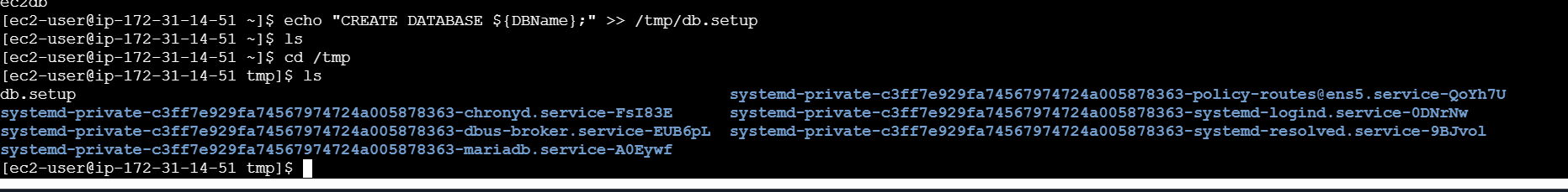
Cat db.setup
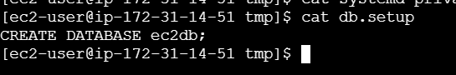
Show databases: it will be like that
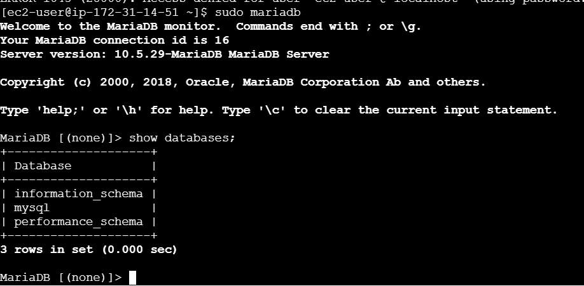
It wants to change the database “use mysql” use this command
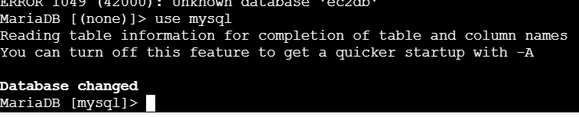

- Insert some dummy data.
CREATE DATABASE company_db => it will create name
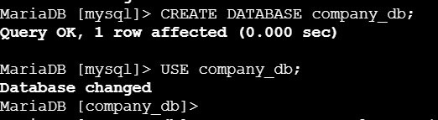
Let’s create a table named employees with realistic columns:
Explanation:
- emp_id → unique employee ID (auto increments)
- first_name / last_name → employee names
- department → department name
- salary → salary in rupees or dollars
- hire_date → date the employee joined

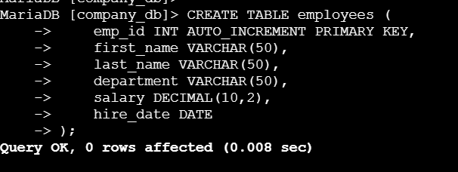
Insert dummy data
Now insert a few sample employee records:
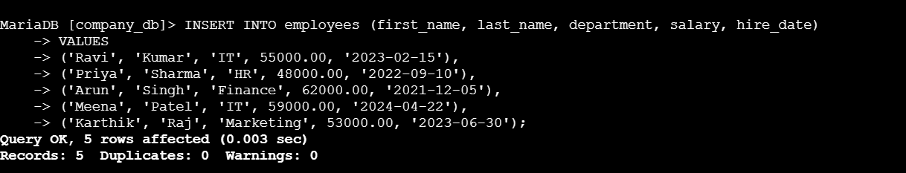
View the data
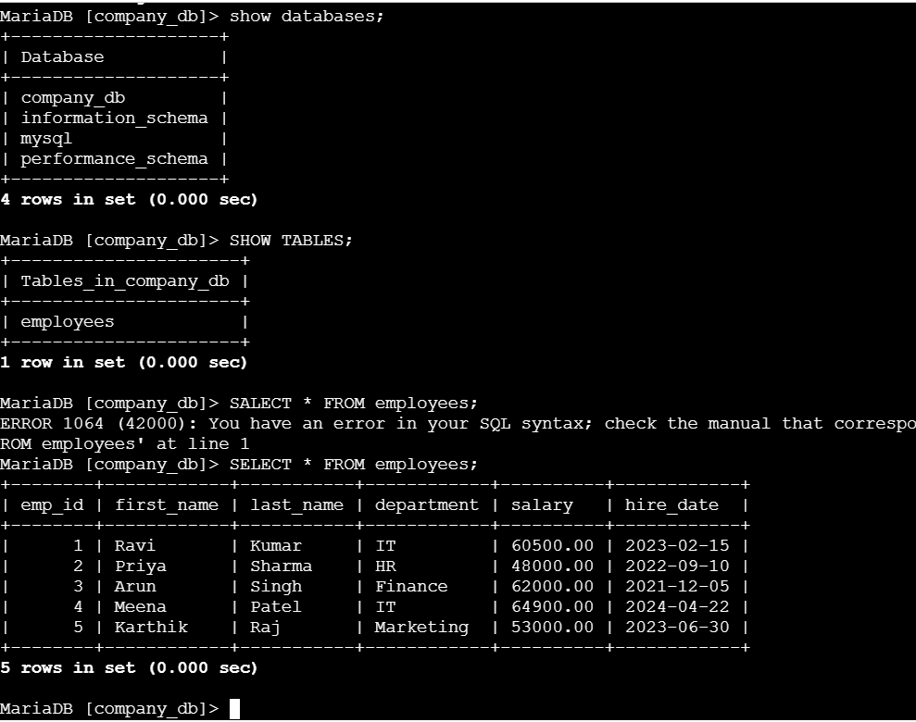
SELECT * FROM employees;
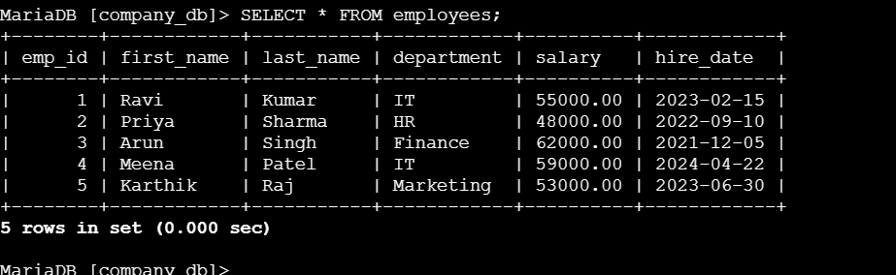
If you want specific depart ment you can give command like that
SELECT * FROM employees WHERE department = 'IT';
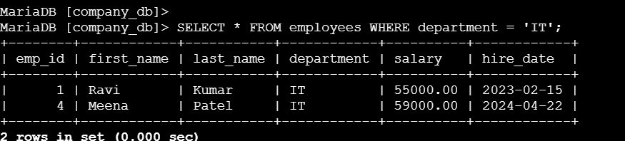
-- Find employees in IT department
SELECT * FROM employees WHERE department = 'IT';

-- Increase salary by 10% for IT department
UPDATE employees SET salary = salary * 1.10 WHERE department = 'IT';
We can see the difference
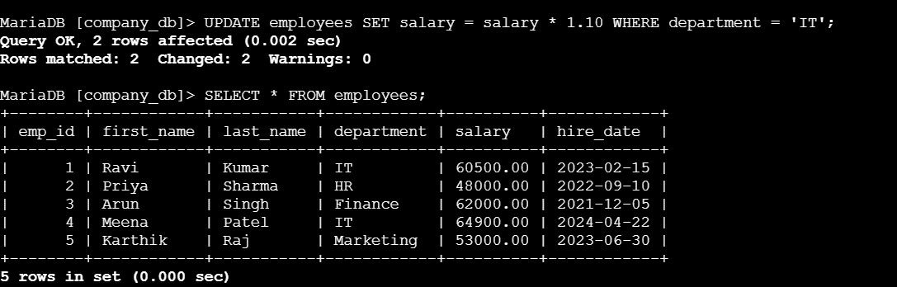
-- Find employees who joined after 2023
SELECT first_name, last_name, hire_date FROM employees WHERE hire_date > '2023-01-01';

-- Delete one employee (example)
DELETE FROM employees WHERE emp_id = 3;

- Take a backup of dummy data on EC2.
Take a backup (dump) of your database

🪄 Command if your root user works with sudo (no password)
sudo mysqldump company_db > /tmp/company_db.sql

Verify the backup file
Check file size:
ls -lh /tmp/company_db.sql

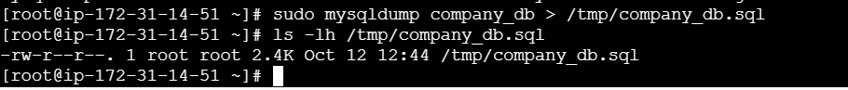
head /tmp/company_db.sql
That means your backup file is successfully created.
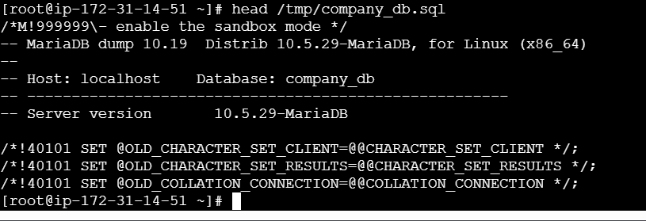
Summary — main backup command
If you just want to back up the data manually:
sudo mysqldump company_db > /tmp/company_db.sql
seeing our data
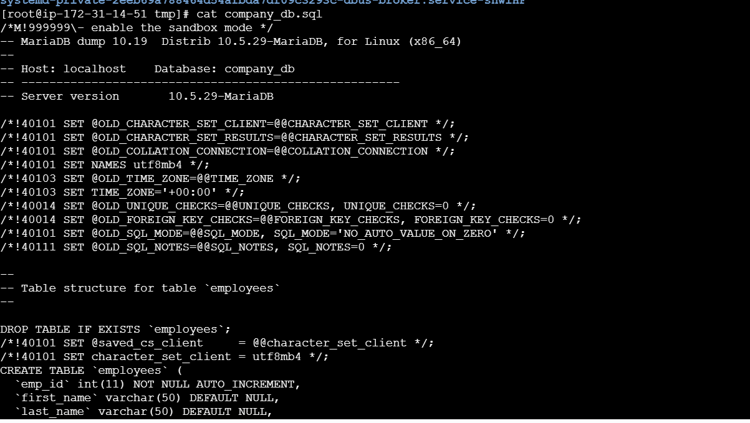

- Launch MariaDB RDS instance.
- Migrate database from EC2 to RDS.
- Install MySQL DB on EC2.
- Launch MySQL RDS image.
- Configure Multi-AZ.
- Take backup of DB and restore the DB.
- Create read replica.

